## **ARK-1– CANSAT**

ARK-1 is a custom PCB designed for CANSAT. At its core is the **ESP32-S3-WROOM**, which handles sensor interfacing, data logging, and wireless telemetry. Each subsystem was designed with **redundancy, stability, and integration** in mind.

### **1. Power Supply Subsystem**

* **Input:** 5V external battery pack
* **Regulation:**  
  + TLV76733 → 3.3 V for ESP32, MPU6050, HC-12
* **Decoupling & Filtering:** ceramic capacitors to stabilize voltage rails
* 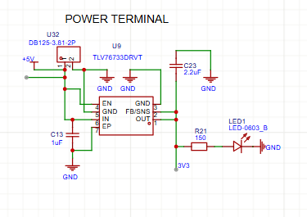**Protection:** Reverse-polarity diode and solid ground planes

### **2. USB Interfaces**

**Two programming/debugging options:**

* **Native USB (ESP32-S3):** Direct flashing and serial monitoring with TVS diode protection.

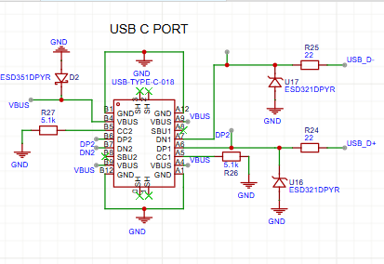

### **3. Microcontroller Core – ESP32-S3**

Manages sensor data, telemetry, logging and Ignition of pyros

* **I²C:** all sensor
* **UART:** E32-900T30D RF module
* **GPIOs:** MOSFET ignition drivers, arming switches, LEDs,

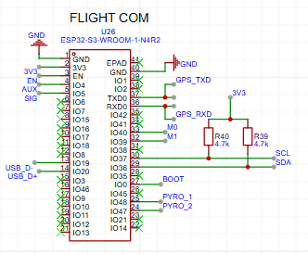

### **4. Ignition Control Subsystem**

* **MOSFET Drivers:** AO3400 MOSFETs with 220 Ω gate resistors and 10 kΩ pull-downs
* **Safety:** Hardware arming switch, software enable logic, and manual acknowledgment button
* **Connections:** Screw terminals for secure e-match attachment

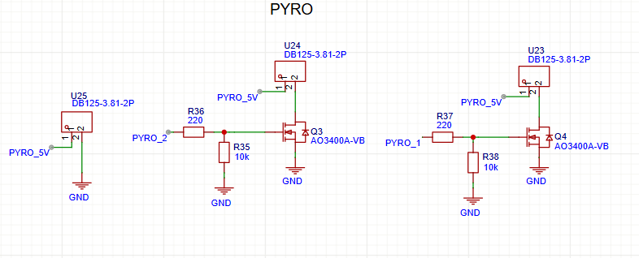

### **5. Sensor Subsystems**

**a) pressure sensor:** High-pressure measurement, SDI/SCK connected to ESP32 GPIOs, logic at 3.3 V

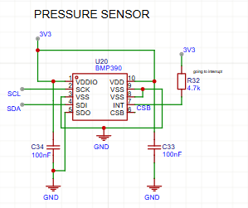

**b) Accelerometer/Gyroscope (MPU6050):** I²C motion sensing for vibration analysis, SDA/SCL connected to ESP32, powered at 3.3 V

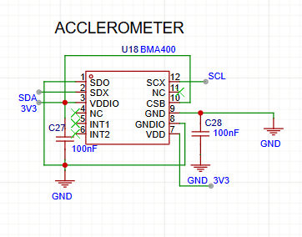

**c) Temperature Sensor (SHT31-DIS-B):** I2C with shared SDA/SCL , powered at 3.3 V

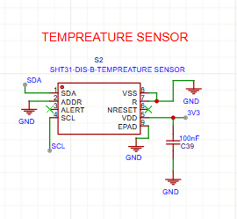

**d) Magnetometer Sensor (LISMDLTR):** I2C with shared SDA/SCL, powered at 3.3 V

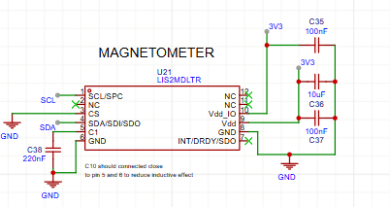

**e) UV Sensor (VEML6075):** I2C with shared SDAT/SCLK, powered at 3.3 V

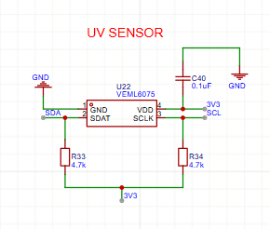

**f) Navigation Sensor (VEML6075):** I2C with shared SDA/SCL, powered at 3.3 V

* UART WITH TXD/RXD, powered at 3.3 V
* With EXTERNAL ANTENA
* It provides robust and accurate positioning data needed for navigation, flight path

monitoring, and landing location.

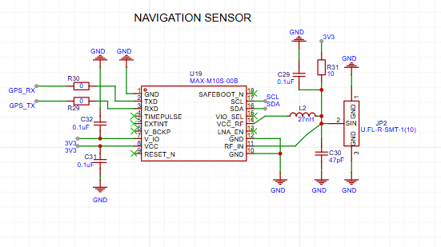

**g) GIGER COUNTER TERMINALS:** SDA/SCL connected to ESP32, powered at 3.3 V

A Geiger counter is primarily used for detecting and measuring ionizing radiation, such as alpha particles, beta particles, and gamma rays.

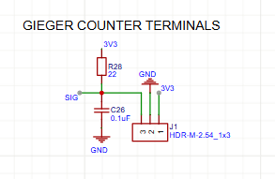

### **6. Telemetry Subsystem**

* E32-900T30D RF module connected via UART
* Powered at 3.3 V, supports up to 8 km wireless maximum range
* Transmits live data of all sensors

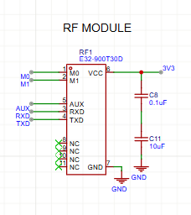

* **Switches:** ESP32 reset, manual ignition acknowledgment, and dedicated arming switch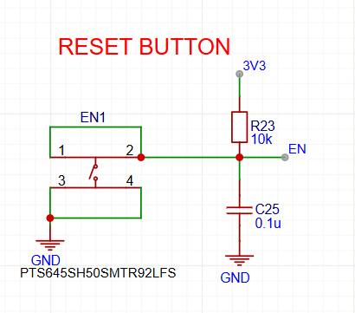

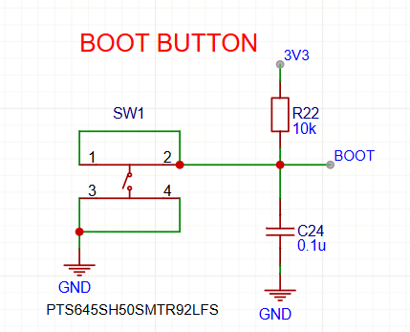

### **7. Testing Line**

### Allows dry-run testing of sensors.

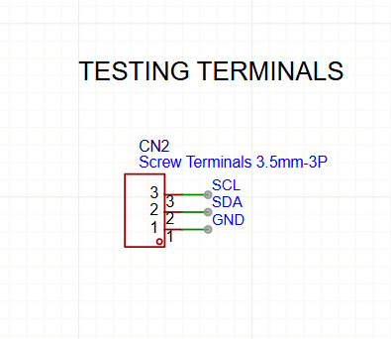

**Blueprint Reflections- CHALLENGE FACED**

Designing ARK-1 was an immersive and rewarding journey. Every subsystem presented unique challenges, and each decision taught me something new about electronics design and system integration.

**1. POWER SUPPLY:**

During the power supply design, I initially selected an AMS LDO for regulation. However, after reading a discussion on Reddit about stability and dropout voltage, I switched to the TLV series, which meant rewriting the schematic and rechecking the voltage rail allocations for sensors, servos, and the ESP32.

**2. Sensor Integration**

* + Different sensors used **I2C, UART** — managing bus conflicts and ensuring stable communication was tricky.
  + Required careful address mapping and pull-up resistor handling.

Working on the sensor subsystems was also challenging. Connecting the UV SENSOR, PRESSURE SENSOR and all sensors to ESP32 with only I2C protocol, so finding the sensors in a way that it’s all having communicate with the different I2C address, paying special attention to the grounding and decoupling pins to ensure stable I2C communication.

**3. Dual-Core Synchronization**

* + Splitting tasks between **Core 0 (sensors/telemetry)** and **Core 1 (logging)** led to timing issues.
  + Mutexes and queues were needed to prevent data corruption.

As we use many sensors, we required datalogging and so we chose dual core microcontroller for that.

**4. USB interface**

For the USB interface, selecting the correct resistor values and protection was critical. I first considered standard TVS diodes, but their voltage rating was insufficient for my design, so I switched to ESD321DPYR diodes to ensure reliable ESD and surge protection

**5. Pyrotechnic Safety**

* + Firing circuits needed **fail-safe logic** to avoid accidental ignition.
  + Redundant backup (Pyro 2) required delay-based conditional logic.

The remote ignition system was inspired by BPS Space’s designs, giving me a real-world reference for safe MOSFET-based pyro control.

**6.Telemetry Reliability**

* + Real-time data transmission under noisy RF environments was unstable.
  + Required **error-checking and logging** fallback.

**7. Radiation Sensor (Geiger Counter)**

* + Its pulse-based output required **interrupt-driven counting**.
  + Handling this without blocking other tasks was challenging.

**8. Environmental Conditions**

* + Pressure, temperature, and vibration changes during ascent/descent stressed the sensors.
  + Required filtering and calibration for accurate readings.

**9. Space Constraints**

* + Packing multiple sensors, GPS, RF, SD card, and pyro circuits into a **CanSat-sized body** while keeping wiring neat was a real hardware challenge.

I also integrated features like auto-programming, pushbuttons, and test LEDs after referencing videos and tutorials online. Because my Cansat is custom board.

Designing the PCB layout was a major learning curve. I focused on strategic placement of components, differential trace routing, and minimizing cross-talk between high-current ignition paths and sensitive sensor signals. Each iteration involved improving the routing, optimizing ground planes, and ensuring clear separation of power and signal lines.

Overall, the experience taught me patience, attention to detail, and the importance of research and iteration. I gained practical insights into designing compact, reliable, and safe electronics systems while understanding how each component—from voltage regulators to RF modules—impacts the overall performance of the PCB. I also understand the key requirements of all components which are used in Cansat , As I made it a custom so finding out many new things which are required to make it custom.

These challenges taught the importance of **modularity, redundancy, and synchronization** in aerospace systems — small-scale CanSat projects mirror the same engineering hurdles faced in real satellites.